Time Series Test Questions

Given the data below answer the following questions:

|  |  |
| --- | --- |
| $$x_{1}$$ | 6 |
| $$x_{2}$$ | 8 |
| $$x_{3}$$ | 13 |
| $$x_{4}$$ | 12 |
| $$x_{5}$$ | 10 |
| $$x_{6}$$ | 7 |
| $$x_{7}$$ | 4 |
| $$x_{8}$$ | 2 |

a. Calculate ${\hat{γ}}_{0}$

x = c(6,8,13,12,10,7,4,2)

var(x)*7/8

c. Calculate ${\hat{ρ}}_{0}$

$${\hat{ρ}}_{0}=1$$

b. Calculate ${\hat{ρ}}_{1}$ and how many pairs were used to find this estimate?

plotts.sample.wge(x)

$${\hat{ρ}}_{1}=.546$$

7 pairs

c. Which pairs would be used to calculate ${\hat{ρ}}_{6}$? (2,8) and (4,6)

f. Given the model: ${(1-.5B)X}_{t}=a_{t}$ Calculate (“by hand” and show the steps) $X_{8+1}=X_{9}$

$${\hat{X}}_{9}= .5\left(2\right)+\left(1-.5\right)\left(7.75\right)=4.875$$

Check: fore.arma.wge(x,phi = .5, n.ahead = 2)

Match the Realization with the ACF:

|  |  |
| --- | --- |
| Realization | ACF |
|  |  |
|  |  |
|  |  |
|  |  |
|  |  |

Match each model on the left with a Spectral Density on the right … each spectral density will be used only once and process of elimination may need to be used.

|  |  |
| --- | --- |
| AR(1) $ρ_{1}= -.95$ |  |
| AR(2) |  |
| AR(4) |  |
| ARIMA (1,2,1) |  |
| ARIMA (0,0,0) with s = 12 |  |
|  |  |
|  |  |

Multiple Choice:

What type of filter is the 10-point moving average filter?

A. Low Pass

B. High Pass

C. Neither

D. Could be either

What type of filter is the first difference filter?

A. Low Pass

B. High Pass

C. Neither

D. Could be either

What type of filter is the Butterworth filter?

A. Low Pass

B. High Pass

C. Neither

D. Could be either

Which is not true about an MA(q) process?

a. It creates dips in the autocorrelation function.

b. It is already in GLP form.

c. It’s autocorrelations ( $ρ_{k})$ are 0 for k > q.

d. It is always stationary.

e. They are invertible if the roots are outside the unit circle.

Factor Tables

Forecasts

What type of models will oscillate above and below the sample mean and eventually converge to the sample mean?

A. AR(1) positive phi

B. AR(1) negative phi

C. AR(2) complex conjugate roots.

d. AR(4) with two sets of complex conjugate roots

e. airline models

f. ARIMA(0,1,0) models

g. signal + noise models

What type of models will simply repeat forecast $X_{t+1}$ to be $X_{t}$?

A. AR(1) positive phi

B. AR(1) negative phi

C. AR(2) complex conjugate roots.

d. AR(4) with two sets of complex conjugate roots

e. airline models

f. ARIMA(0,1,0) models

g. signal + noise models

Assuming the Sunspot data is stationary (Base R dataset: sunspot.year), what is the model ID (ARMA(p,q)) that is most favored by the AIC?

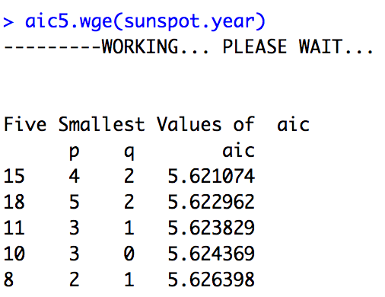

Which model do you think is most appropriate/useful for forecasting the Sunspot data?

Provide at least 2 arguments as to why the model you selected is more useful than the other two in predicting the next 10 years of sunspots.

$${(1-.723B-.283B^{2}+.519B^{3})X}_{t}={(1+.60B)a}_{t}$$

$${(1-B^{12})(1-B)X}_{t}=a_{t}$$

$${(1-1.06B+ .4B^{2})(1-B^{10})X}_{t}=a_{t}$$

Sunspot Data:





$${(1-.723B-.283B^{2}+.519B^{3})X}_{t}={(1+.60B)a}_{t}$$

plotts.true.wge(100,phi = c( 0.723, 0.283, -0.519), theta = -.6)



f.arma3_1 = fore.aruma.wge(sunspot.year,phi = c( 0.723, 0.283, -0.519), theta = -.6, n.ahead = 20, lastn = TRUE ) #Poor Visual Forecasts

aseARMA3_1 = mean((f.arma3_1$f - sunspot.year[(length(sunspot.year)-19):length(sunspot.year)])^2)

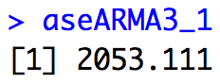



x = gen.aruma.wge(1000,d= 1, s= 12)

plotts.sample.wge(x)



f.12.1 = fore.aruma.wge(sunspot.year,d = 1, s = 12, n.ahead = 20, lastn = TRUE, limits = FALSE )

ase.12.1 = mean((f.12.1$f - sunspot.year[(length(sunspot.year)-19):length(sunspot.year)])^2)

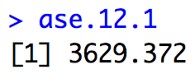



f.10.ar2 = fore.aruma.wge(sunspot.year,phi = c(1.06,-.4), s = 10, n.ahead = 20, lastn = TRUE, limits = FALSE )



x = gen.aruma.wge(1000, phi = c(1.06,-.4), s = 10)

plotts.sample.wge(x)

ase.10.ar2 = mean((f.10.ar2$f - sunspot.year[(length(sunspot.year)-19):length(sunspot.year)])^2)

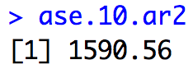

The ARIMA(2,0,0) with s = 10 is the most thought to be the most useful model in terms of forecasting behavior, spectral density, ACF and ASE.